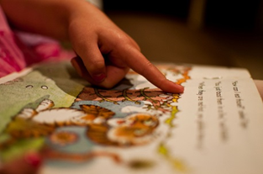
Russell Lower School
Reading with a child at home guide – FS
When reading with a child please:
- Check that they have chosen a book from the correct shelf.
- Help the child to choose a new book each day if necessary.
- Encourage them to hold the book and turn the pages themselves.
- Discuss the front cover. What might the book be about? Who could the main characters be? Have they read a book like this before? By this author?
- Ask them to read the title of the book to you.
- Encourage the child to follow the text by using their finger to point underneath the text if necessary. As soon as possible, ask them to just follow with their eyes instead of their finger.
- Please do make comments in the reading diary and sign your name.
- Discuss the content/pictures/themes/characters/settings in the books to check comprehension.
- Encourage the child to use the following strategies if they cannot read a word:
Use the pictures – look at the pictures for clues.

Read around it – read the whole sentence (leaving out the word that they are stuck on), can they work out the word?

Sound it out – sound out the word using their phonics (if it is phonetically regular).

Read it on sight – think about the sight words that they know. Do I know another word like it…if I know fire, I know wire etc.

