Monday 4th January 2021
Dear Parent/Guardian,
Remote Learning Provision
As you may be aware, there has been a lot of news around the reopening of schools towards the end of last week and over the weekend. We wanted to take this opportunity to let you know that as things currently stand Russell Lower School will be open as of Tuesday 5th January 2021 to all children.
You will no doubt also be aware that some schools have year groups returning at a later date as advised by the Government and some local schools have taken the decision to close fully due to staffing issues which prohibits them from opening in a safe and manageable way.
We recognise how difficult it will have been to decide whether to send your child/ren into school this coming week or not. Please be assured that although the attendance will still be marked as unauthorised, we will not be issuing any fines and will support your child’s education but providing home learning over the course of this week. This will be emailed home and you will be able to contact the class teacher through their email address. All addresses take the format of classname@russell-lower.co.uk for example robinclass@russell-lower.co.uk.
There is of course also still the chance the Government could call for a full closure of schools except for vulnerable children and children of critical workers over the course of the week or beyond. If this is the case we will communicate again about the next steps.
In order to prepare for any potential closure of bubbles as we move into a new term or a National lockdown and a requirement to move to remote learning we wanted to remined you of some of the things we wrote to you about back in November 2020 and also add a little more detail to what our remote offer would look like at Stage 3 and 4.
As you will be aware we have already gained many of your views and position in terms of ability to access online remote learning and have sent out a follow up email today to those we have not heard back from. Could we ask that you please make sure, if you have received this email today, you reply as soon a possible so we know which families may require support with the loaning of devices.
In order to support you we have put together a parent and pupil guide on Google Classroom as well as a Code of Conduct. These can be found on the website under the section to do with remote learning and are also attached where you will also be able to view our staged approach and policy.

How remote learning will work for Stage 3 (full bubble isolation) and 4 (National Lockdown) at Russell Lower
If your child/ren’s bubble is required to isolate (stage 3) or we all move to a National Lockdown (stage 4) teachers will provide live teaching via Google Classroom for 4 sessions a day (see timings below).
These timings will be kept to and will require your child/ren to log on to their Google Classroom at the set time and click the Meet link at the top to join – they will not be able to join before their teacher has joined.
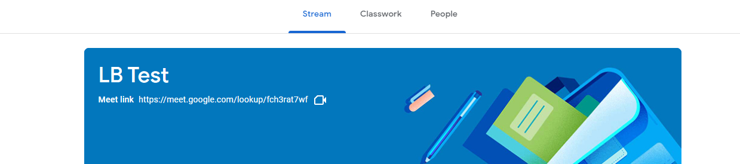
Google Meet link
The subject of these sessions could change on a daily basis but the times will remain set. We appreciate that not all children may be able to join the ‘live’ teaching or may wish to view it again at a later date and therefore these lessons will be recorded by the teacher and shared to the classroom area. Please ensure your child/ren joins with their camera off and microphone muted and remains this way unless requested to unmute by their teacher.
- 9:15am – 9:35am – Live lesson
- 10am – 10:20am – Live lesson
- 10:20 – 10:50 – Home learning linked to live lesson above
- 10:50 – 11.15 break/physical activity time
- 11:15 – 11:35 – Live lesson
- 11:35 – 11:55 – Home learning linked to live lesson above
- 11.55 – 12:55 – Lunchtime
- 1:00 – 1:20 – Live lesson
- 1:20 – 2:00pm – Home learning linked to live lesson above

For Foundation Stage live teaching will be done through Google Classroom with all follow up work and communication carried out through Tapestry. Please contact your class teacher if you feel you need more support with Tapestry.

How does my child log on to Google Classroom?
Please find attached a guide to support you with this and more information can be found on the ‘remote learning’ section of the website.
Your children will need to log into Google Classroom using their own email address. This is preceded by a number:
- foundation stage - 20
- year one -19
- year two – 18
- year three – 17
- year four – 16
which is then followed by their firstinitialandsurname@russell-lowr.co.uk for example 20bsmith@russell-lower.co.uk if they are in FS or 17bsmith@russell-lower.co.uk if they are in year 3.
In order to first log in their password will be Russell2020. On logging in they will be prompted to change their password. If this is done in your presence please ensure a note of this is kept (preferably in their reading diary for future reference). If the child/ren first log in at school we will add their details to their reading diary for your information.

Please keep in touch with us and do let us know if you’re having any difficulties with remote learning, or if you have any questions.
Thank you for your continued support.
Yours faithfully,
Mrs Louise Bunney Mrs Nicki Walker
Deputy Headteacher Headteacher

