Hi!
We are still here for you.
The School Nurses are still here to support you with any health questions or worries you have.
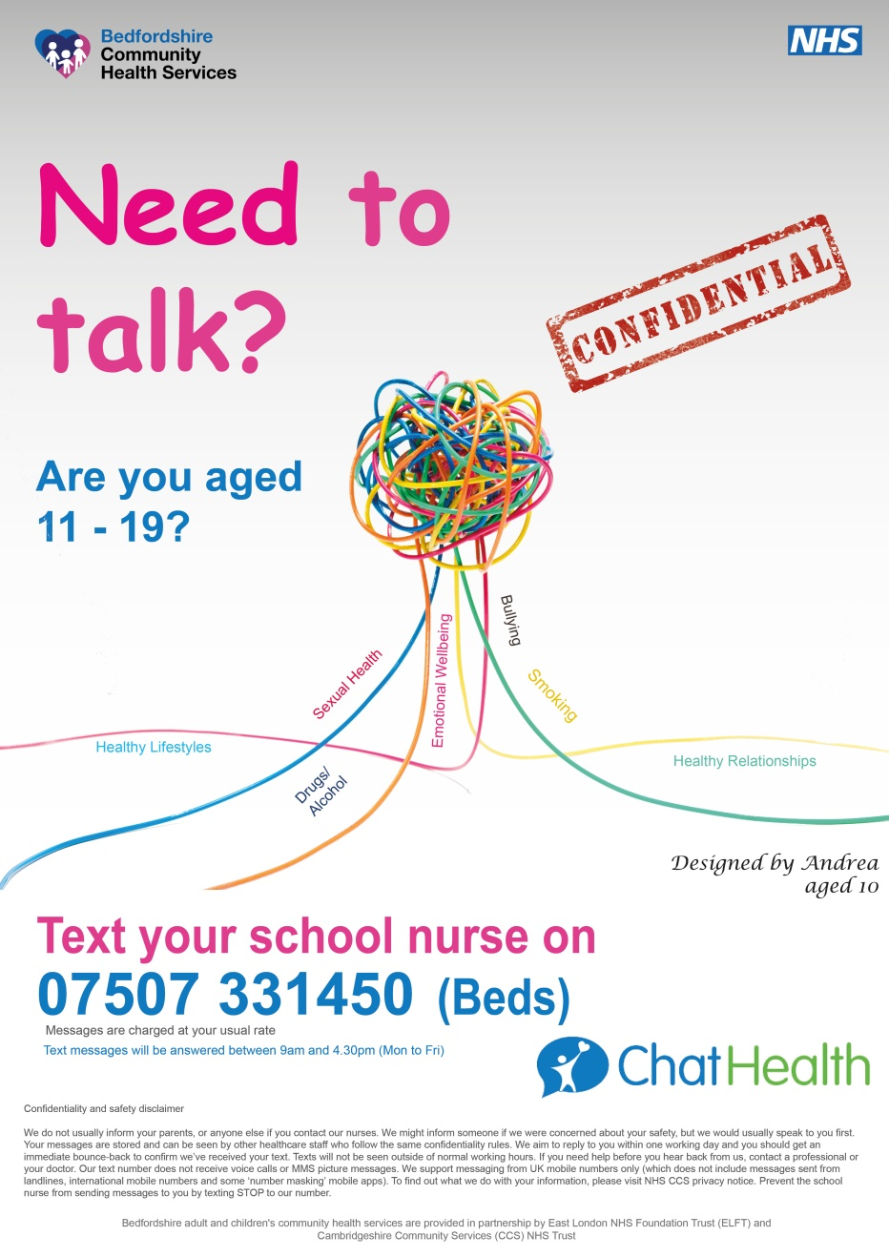
ChatHealth is our confidential text messaging service
9.00am – 4.30pm Monday - Friday
Your messages are answered by a School Nurse and we are here to listen to you.
We are here in the school holidays too.

