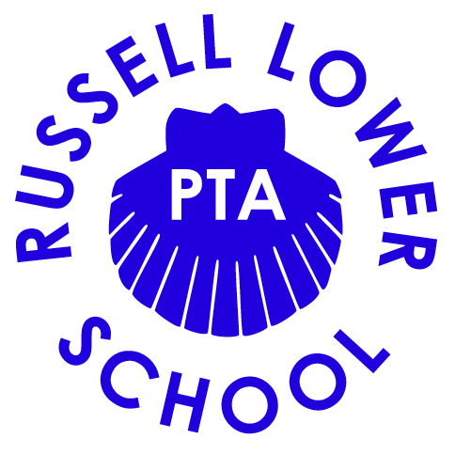

Chair’s report – Thursday 26th November 2020

Welcome all to our last PTA meeting before we break up for Christmas – how it’s almost Christmas I’ll never know…I am so not ready for this!

Firstly, I wanted to say thank you because everyone on the team has pulled together amazingly with everything going on lately. It’s not easy when we can’t actually get together and make it all happen, but we are doing really well! We have obviously been mega busy arranging the ‘The Big Christmas Raffle’ and whilst there have been quite a few hurdles along the way everyone has made a massive effort to help where they can and it looks to be a big success – it shows what a strong PTA team we have!

Not only have we been planning the raffle, but we have also been trying to find more ways to fundraise, and thanks to Lucienne we have managed to get involved with the Round Table this year and will be going out around the streets of Ampthill on the 11th December, with Paul Birley kindly agreeing to be our Santa, and as many volunteers as we can recruit. We hope this will be a fun festive way to raise more funds for school – I for one, am looking forward to it!

And although it’s not fundraising we have been very lucky to be gifted a real Christmas Tree from Woburn Sands Emporium. It will be a wonderful sight for everyone when they enter the school grounds and hopefully put a smile on everyone’s face. I’m really looking forward to seeing that.

We have quite a lot to talk about tonight so I will leave it here, but I just want to finish off by saying we really couldn’t make this all happen without the massive support of everyone here so a big THANK YOU!

Amy

